# Objective

The purpose of this experiment is to investigate the performance of silencers of various designs in terms of their acoustic attenuation. Silencers are commonly used in industry, particularly in the automotive industry where they are placed in the engine intake and exhaust system in order to reduce the transmission of excess noise to the vehicle occupants and nearby pedestrians. To do this, transmission loss data will be acquired for Helmholtz resonators, quarter-wave resonators, perforated resonators, expansion chambers, and absorptive silencers in the absence of mean flow. Additionally, the effects of mean flow on the performance of the Helmholtz resonator will be investigated.

# Experimental Setup

The experiment was performed using two speakers installed opposite one another along a pipe. A resonating chamber was located at one end of the pipe near the speakers and at the other end of the junction a long pipe of constant diameter was installed. At the end of this pipe the various silencers were installed, just upstream of two pressure transducers which were used to measure the transmission loss due to the silencer. For the experiments involving mean flow through the duct, the end of the pipe was attached to a flow bench while the mass flow rate was varied.

# Results

## Part 1: Helmholtz Resonators

Using the classical lumped approach, the volume of the Helmholtz resonator is estimated to be 0.005839 m3 based on the transmission loss spectra. This does not compare particularly well with the actual volume of the chamber, which was measured as 0.004501 m3, representing an error of nearly 30%.

## Part 2: Quarter Wave Resonators

The transmission loss data acquired for the quarter-wave resonator is shown in Figure 1. Based on this data, the estimated length of the quarter-wave resonator is 0.895 m, which compares well with the actual length, 0.854 m.

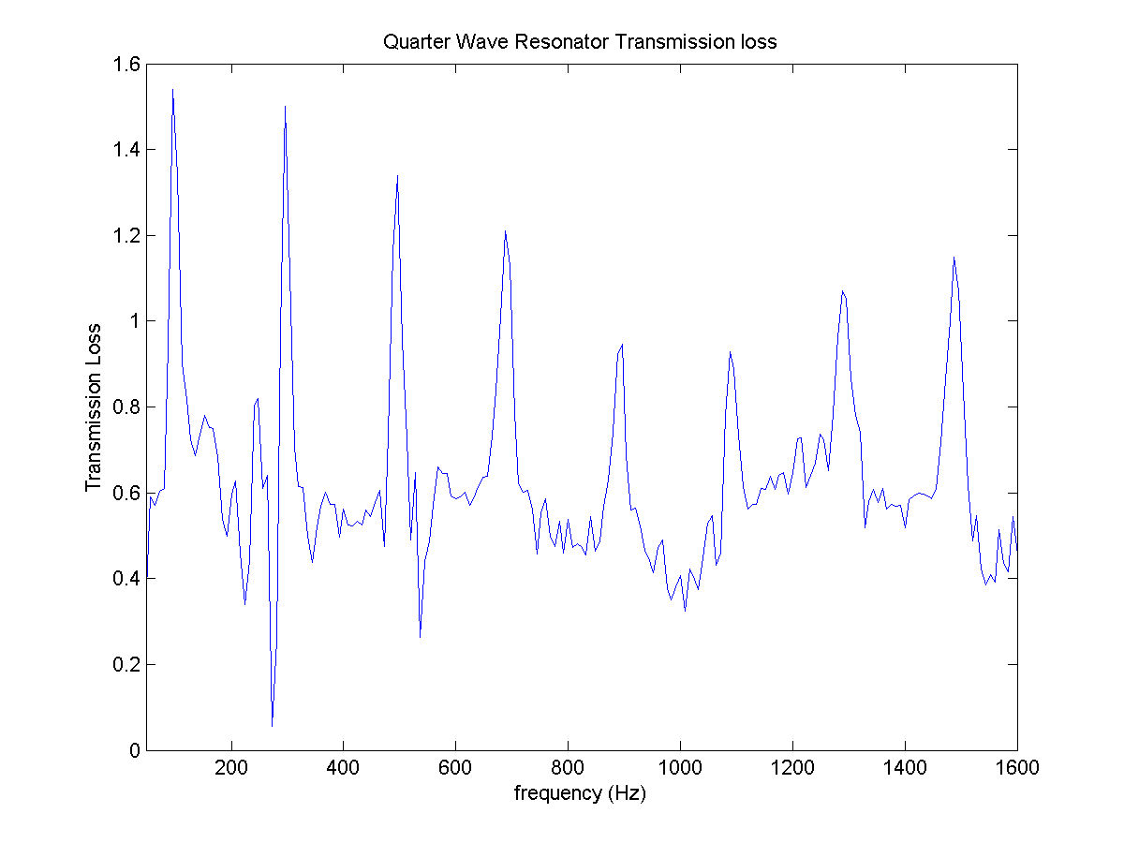

Figure : Transmission loss spectra for the quarter-wave resonator.

## Part 3: Expansion Chambers

Figure 2 shows the measured transmission loss for the expansion chamber. Based on a transmission loss value of 15 at 160 Hz, the estimated diameter of the expansion chamber is 0.162302 m, (corresponding to an area ratio of 11.16) and the estimated length is 0.537030 m.

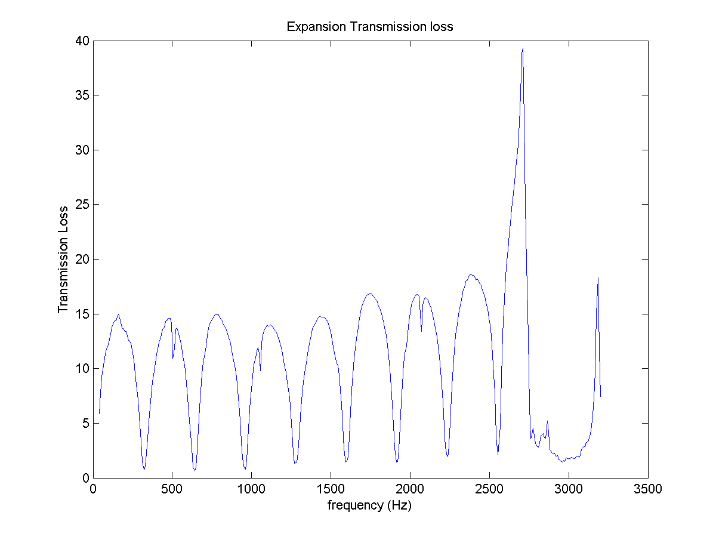

Figure : Transmission loss spectra for the expansion.

## Part 4: Perforated Resonators

The length controlled resonance frequencies for the short and long perforated silencers were estimated to be 2576 Hz and 668 Hz, respectively. From the plots in Figure 3, it is seen that the actual resonance frequencies for the perforated silencers are 2360 Hz and 360 Hz, respectively. The Helmholtz frequencies for the short and long resonators were estimated to be 1620 Hz and 770 Hz, respectively. This trend is in agreement with previous data, as it was expected that the Helmholtz frequency for the short resonator would be less than the corresponding length controlled resonance frequency, and the Helmholtz frequency for the long resonator would be greater than the corresponding length controlled resonance frequency.

|  |  |
| --- | --- |
| Z:\My Documents\Matlab\Coursework\ME 820\Exp 2\Perf short transmission loss.png | Z:\My Documents\Matlab\Coursework\ME 820\Exp 2\Perf long transmission loss.png |

Figure : Transmission loss spectra for (a) short and (b) long perforated silencers.

## Part 5: Filling material effects

The effects of filling material on the transmission loss spectra are shown in Figure 4. The spectra show a much more broadband character than that for the other silencers tested. Very low frequencies are relatively unaffected by the absorptive material, whereas mid to high range frequencies are significantly attenuated. Additionally, as the frequency increases the transmission loss asymptotes to a value of roughly 17.

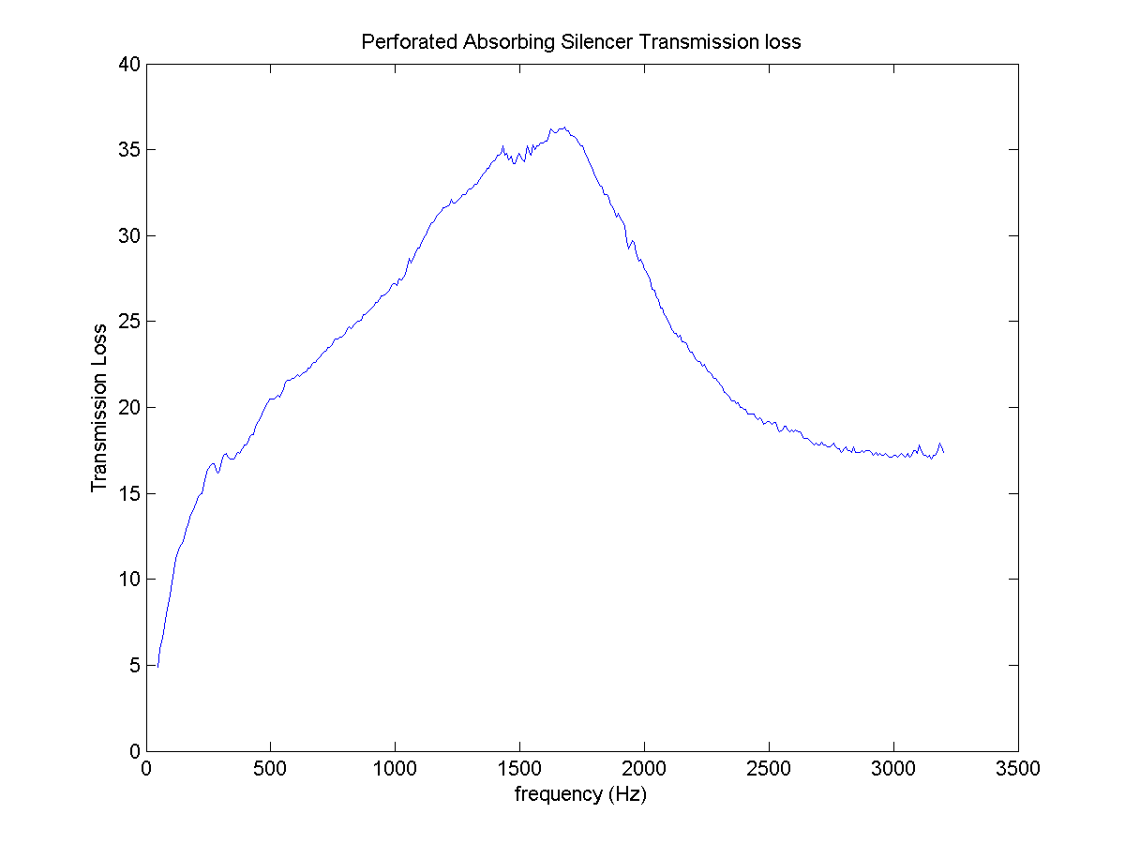

Figure : Transmission loss data for the absorptive silencer.

## Part 6: Mean flow effects

Figure 5 shows the effect of the mean flow on the acoustic attenuation properties of a Helmholtz resonator. Clearly, even low values for the mean flow significantly reduce the effectiveness of the Helmholtz resonator at low frequencies. As the mean flow Mach number is increased, the low frequency transmission loss peak reduces in amplitude and shifts to a slightly higher frequency while becoming slightly more broadband in character. The high frequency transmission loss peak is unaffected by the mean flow rate.

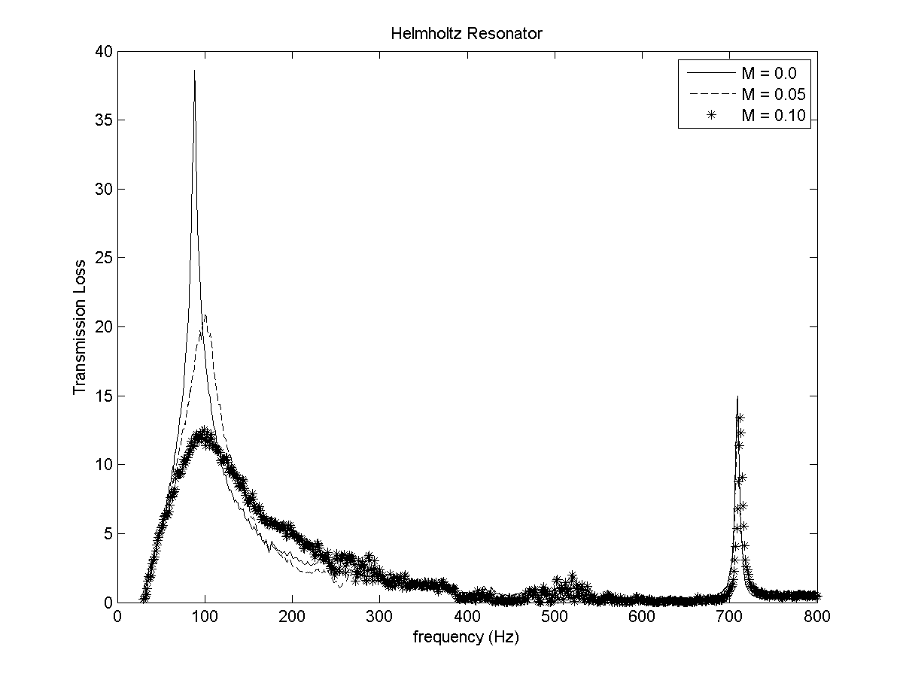

Figure : Effect of mean flow on acoustic attenuation of a Helmholtz resonator.